**Read Across America Week**

**March 2-6**

**To help spread our love for reading we will celebrate Read Across America Week. Below are the books and themes we will highlight each day.**

**Monday March 2nd**- Mix Match Day- Wear your mismatched clothes!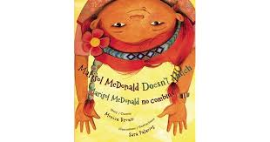

**Book- Marisol MacDonald Doesn’t Match By: Monica Brown**

**Tuesday March 3rd-** **Love Your Hair Day**- Wear your hair any way you

Want to express yourself!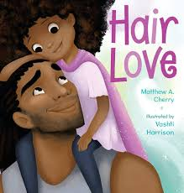

**Book- Hair Love By: Matthew Cherry**

**Wednesday March 4th-** **Career Day**- Dress for your future career!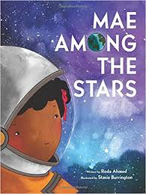

**Book- Mae Among the Stars By: Roda Ahmed**

**Thursday March 5th-** **Sports Day-** Represent your favorite sports team!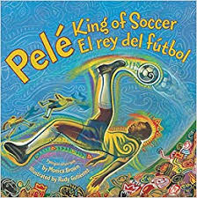

**Book- Pele’ King of Soccer By: Monica Brown**

**Friday March 6th-** **Favorite Book Character day**- Dress up like your

favorite book character!